Ebbsfleet Development Corporation (EDC) – Guaranteed Interview Scheme

Introduction

EDC is a disability confident committed employer. We are committed to the employment and career development of disabled people. Candidates with a disability are guaranteed an interview if they meet the minimum criteria for a job vacancy (set out in the Job Description ‘essential criteria’). Declaring a disability for the purposes of a guaranteed interview is your decision and is entirely voluntary. This form is separate to your application form; staff involved in interviewing for the post will not see this form.

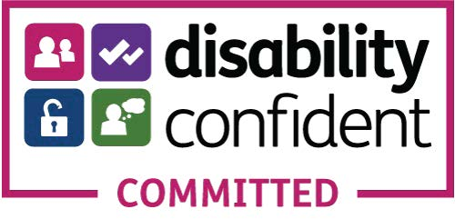

What we mean by disability

The Equality Act 2010 defines a disabled person as someone who has a mental or physical impairment that has a substantial and long-term adverse effect (more than 12 months) on the person’s ability to carry out normal day-to-day activities. We aim to select staff on suitability for the job and welcome your application if your disability does not stop you from doing the job in accordance with our responsibilities as an employer in accordance with the Equality Act 2010.

Declaration:

I consider myself to have a disability as defined above and I would like to apply under the EDC’s Guaranteed Interview Scheme.

Applicant’s signature:

Date:

Any false declaration of disability to obtain an interview may invalidate any contract of employment. All information provided will be dealt with in accordance with our Data Handling Security Policy and Data Retention & Disposal Policy.

I give my consent to the Ebbsfleet Development Corporation processing the special category of personal data supplied in this form for the purposes of the Guaranteed Interview Scheme.

I understand that I may withdraw my consent to the processing of this special category of personal data at any time by notifying: ebbsfleetrecruitment@ebbsfleetdc.org.uk

Attending an interview:

Whether you choose to apply under the EDC’s Guaranteed Interview Scheme or not, you can still ask us to give consideration to making particular arrangements for you when attending an interview.

You can also contact us if you want to discuss the criteria for the job or have questions regarding your application.

If you believe this applies to you, please give details of your disability:

……………………………………………………………………………………………………….

Helping us to help you

We will try to provide access, equipment and/or other practical support to ensure that people with disabilities can compete on equal terms with non-disabled people.

Applicants with disabilities who have any queries about any specific needs should contact James Richardson at ebbsfleetrecruitment@ebbsfleetdc.org.uk

If you have equipment of your own or an interpreter of your choice available for the interview, please provide details.

