

Consultation Report

Thames Way Development Area

July 2021

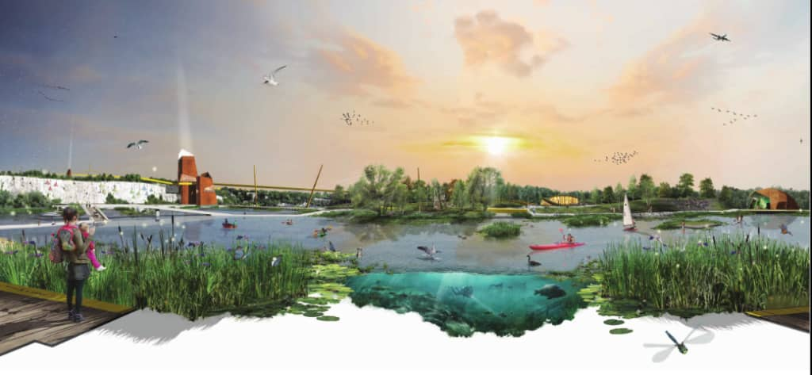

Project: Thames Way Development Area Concept Plan

Client Name: Ebbsfleet Development Corporation

Type of report: Consultation Report

Prepared by: Faith McMath

Date: July 2021

Reviewed by: Linda Elliott

Date: July 2021

Contents

1. Executive summary 4

2. Introduction 5

3. Community engagement and consultation – the approach 7

4. Community engagement and consultation – the delivery 8

5. Results / findings of the public consultation 14

6. Conclusion 34

**Appendices**

Appendix A – Letter sent to key stakeholders inviting them to an online meeting

Appendix B – List of key stakeholders

Appendix C – Letter sent to other stakeholders

Appendix D – List of other stakeholders

Appendix E – Bulletin distributed to residents and businesses

Appendix F – Poster

Appendix G – Example advert

Appendix H – Social media strategy and examples of posts

Appendix I – Media release

Appendix J – Letter sent in response to request for a telephone surgery

Appendix K - Substantive emails received

# 1. Executive summary

This report provides a summary of the public consultation process undertaken by Ebbsfleet Development Corporation about the draft Concept Plan for the Thames Way Development Area.

The consultation took place between 11 May 2021 and 8 June 2021. It was widely promoted with letters to stakeholders, printed bulletins delivered to homes and businesses closest to the proposed site, posters displayed in the local area, social media and adverts in the local press. There was also a project website which featured a video animation. People were invited to provide feedback via an online survey, email, Freepost or Freephone.

While it was not possible to hold physical meetings about the proposals due to Covid-19 restrictions, the engagement included four online key stakeholder meetings held on Monday 17 May and Tuesday 18 May 2021 and three webinars which were held on Wednesday 19 May, Saturday 22 May and Wednesday 26 May 2021. A telephone surgery was also held on Tuesday 25 May 2021.

68 individuals completed the online survey and a further 13 people submitted a postal survey. Overall, 70% submitted positive comments about the draft Concept Plan. Many people were encouraged by the idea of opening up access to Blue Lake and the proposed increased leisure opportunities. There were also positive comments about the proposal to replace the existing Wastewater Treatment Works and how this would help to reduce odour.

The main concerns / points raised about the proposal were:

* The area does not need any more housing
* Lack of infrastructure/schools/healthcare
* Potential impact on wildlife
* Concerns over access to Blue Lake for fishing
* Increased traffic
* Access and parking

When asked for views on whether to realign the Thames Way, responses were split fairly equally, with 46% favouring realigning the Thames Way and 43% supporting leaving it as it is. 11% answered “other” and their comments are summarised in Table 3 on page 22.

# 2. Introduction

**Overview**

This report has been prepared by Athene Communications on behalf of Ebbsfleet Development Corporation (EDC) to summarise its public consultation regarding the draft Thames Way Development Area Concept Plan.

**Background of the site and the proposed draft Concept Plan**

EDC is starting the journey to realise the potential that exists in and around Blue Lake, at Thames Way. The draft Concept Plan focuses on creating a new lakeside neighbourhood with a range of benefits for residents of Ebbsfleet Garden City, Northfleet and the wider community.

The area under consideration is to the north and south of Thames Way between the A2260 and Springhead Road. It includes Blue Lake and the land around it, the River Ebbsfleet corridor, as well as the existing wastewater treatment works and its surroundings.

The draft Concept Plan aims to create a high-quality, new neighbourhood from land and lake resources which it had not previously been considered possible to develop. It seeks to:

* Open up public access to Blue Lake by raising the bed of the lake, making it a safe, accessible and enjoyable space for the public. This will help EDC to deliver Blue Lake Park, one of the seven major parks planned for the Garden City
* Protect and enhance the variety of animal and plant life in the area
* Build a new landmark Leisure Facility – addressing the shortage of leisure amenities in the Garden City and surrounding area
* Establish a new lakeside community – providing new homes
* Replace the existing wastewater treatment works, to within a building on the existing site, creating a modern, green, quiet, clean and odourless facility
* Create new community facilities including a new community centre
* Improve transport and pedestrian links between this area, the existing communities and Ebbsfleet Central (the areas around Ebbsfleet International Train Station). This includes the potential to amend the alignment of Thames Way.

A copy of the draft Concept Plan is shown below in ***Figure 1.***

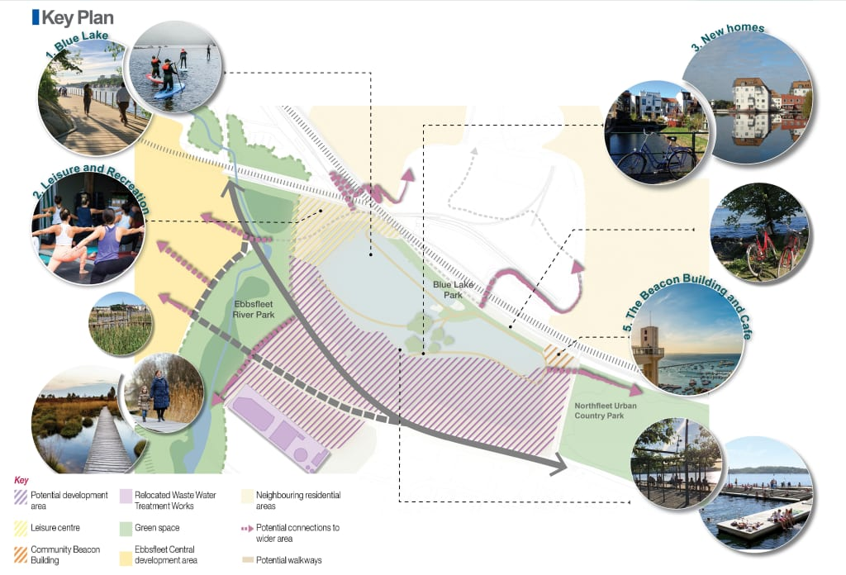

***Figure 1 – The draft Concept Plan***

# 3**. Community engagement and consultation – the approach**

The core objectives underpinning the consultation were to:

o Present the draft Concept Plan

o Understand any issues and concerns about the proposal and respond to any issues raised

o Inform the next stage of the design process

To achieve these objectives, the approach to community consultation was delivered in five key steps:

1. Engagement with key stakeholders, including online meetings

2. Promotion of the consultation and the draft Concept Plan

3. Stakeholder meetings and webinars

4. Capture and analysis of feedback and responses

5. Preparation of the Consultation Report

# 4. **Community engagement and consultation – the delivery**

This section outlines the activities undertaken as part of community engagement and consultation. The consultation took place between 11 May and 8 June 2021.

**Engagement and consultation with stakeholders**

1. Key stakeholder online meetings

A letter was sent via email on Tuesday 11 May 2021 to key stakeholders explaining that EDC was bringing forward a draft Concept Plan for the Thames Way Development Area and inviting them to an online meeting to discuss the proposal in more detail. An example of the letter is attached at ***Appendix A.*** A list of recipients is shown in ***Appendix B*.**

Online meetings took place via Zoom in May and were hosted by Michael Samways (EDC) and Kelly Linay (Athene Communications). A list of stakeholder meetings and attendees is shown in the table below (**Table 1**)**.**

***Table 1***

|  |  |  |
| --- | --- | --- |
| **Webinar** | **Name** | **Organisation/ role** |
| Mon 17 May  12-1pm | Cllr Elizabeth Mulheran | Gravesham Borough Council (GBC) Northfleet South ward councillor |
| Cllr Gurbax Singh | GBC Northfleet North Ward – joined at 12.25pm |
| Mon 17 May  4-5pm | Cllr Jenny Wallace | GBC Pelham ward councillor |
| Tues 18 May  12-1pm | Cllr Shane Mochrie-Cox | GBC Coldharbour ward councillor and Cabinet Member for Community & Leisure and Younger Persons’ Champion |
| Cllr Dr Lauren Sullivan | Kent County councillor for Northfleet and Gravesend West and ward councillor for GBC’s Northfleet North |
| Tues 18 May 3.30-4.30pm | Cllr Lesley Howes | Swanscombe and Greenhithe Town Mayor and member of Stone Parish Council |
| Graham Blew | Town Clerk, Swanscombe and Greenhithe Town Council |
| Martin Harding | Assistant Town Clerk, Swanscombe and Greenhithe Town Council |
| Cllr Lorna Cross | Swanscombe and Greenhithe Town Council |

A further evening stakeholder meeting was organised for Thursday 27 May at 7.00 pm at the suggestion of Cllr Sullivan. All councillors who had not signed up to attend a stakeholder briefing were emailed with an invitation to attend. One councillor signed up (Cllr Baljit Hayre, GBC Pelham ward) but did not attend on the night.

A summary of the key points raised at the meetings is included in section 5.

1. Letter to other stakeholders

A letter was sent by email on Wednesday 12 May 2021 to other identified stakeholders about the proposed development. One letter was sent via first class post and four stakeholders were contacted via the contact us form on their website. The letter included details about the proposal, an invitation to attend the webinars and a copy of the printed bulletin which was due to be distributed to residents (see below). A copy of the letter is attached at ***Appendix C.*** EDC directly contacted the Dartford, Gravesham and Swanley Clinical Commissioning Group (CCG) and the Thameside Works Angling Preservation Society.

A list of stakeholders who were contacted is attached at ***Appendix D***.

**Promoting the public consultation**

Our aim was to promote the public consultation and the details of the webinars and project website to ensure as many local people as possible were informed about the proposal, able to attend the webinars and to provide feedback.

Bulletin distributed to residents and businesses

Approximately 10,000 copies of a six-page colour A4 bulletin about the draft Concept Plan and the consultation were delivered to residents and businesses closest to the proposed site.

The bulletin was distributed on 11 and 12 May 2021. The distribution area for the bulletin can be seen below in ***Figure 2***.

***Figure 2 – Distribution area for the bulletin***

The bulletin gave details of the draft Concept Plan proposals, the project website and invited people to help shape the plans by attending a webinar or telephone surgery and / or providing their feedback by completing the feedback form which was included as part of the bulletin or via the survey on the website. It also gave details of the consultation email address, Freepost address and Freephone number. A copy of the bulletin is attached at ***Appendix E***.

Posters

70 A4 posters were produced to promote the public consultation. A copy of the poster is attached at ***Appendix F***. These were distributed by EDC from 11 May.

Website

A website was developed with information about the proposal. The site went live on Monday 10 May 2021 at <https://ebbsfleetthameswayconceptplan.commonplace.is>.

The site presented the details of the draft Concept Plan and the main elements of the proposals. It invited people to share their views on the draft Concept Plan via an online survey and encouraged people to sign up for a webinar or a telephone surgery.

Between 10 May 2021 and 5 July 2021, the site received 1,152 unique visitors, with most visits taking place between 10-28 May. 5% of visitors completed the survey, 25% viewed four or more pages. A further 19% viewed 1-3 pages. The graph in **Chart 1** below shows when the site visits took place.

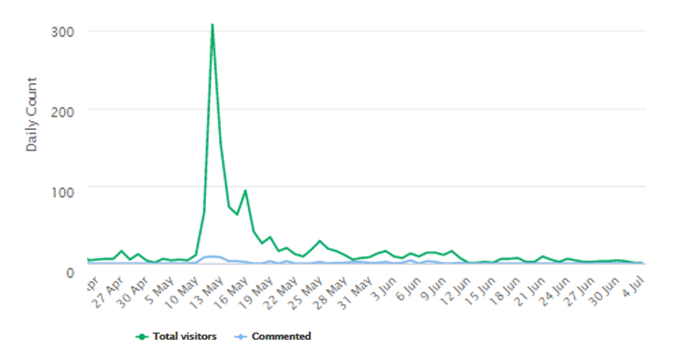

***Chart 1– website visits***

The website has been kept live since the consultation and was updated with details about next steps once the consultation closed.

Video animation

### An [animated video](https://youtu.be/WEgOibK-FHQ) was produced to help bring the draft Concept Plan to life and encourage people to get involved and share their views. This was shared on the Thames Way Development Area draft Concept Plan website, linked to the EDC [YouTube page](https://www.youtube.com/watch?v=WEgOibK-FHQ). It was also promoted via social media (see below).

### 

### Local advertising

Two quarter page adverts appeared in the Gravesham and Dartford Messenger, plus digital adverts appeared on the paper’s website – Kent Online – during the weeks commencing 10 and 17 May. The adverts shared brief details of the draft Concept Plan, webinars and telephone surgery information together with the website address, email and Freepost addresses and the Freephone number. An example is shown at ***Appendix G.***

Social media

A series of social posts were shared by the EDC communications team via the EDC social media accounts to encourage people to visit the project website and to get involved with the consultation. Overall, the Facebook posts about the consultation reached 8,802 accounts in total.

A copy of the social media strategy with the schedule for the posts, together with examples of the posts, are shown at ***Appendix H.***

Media Release

A media release and image about the proposals and the consultation was issued on 12 May 2021 to the local media. A copy of the media release is shown at ***Appendix I.***

**Webinars**

Three webinars were held via Zoom and were attended by a total of 16 members of the public:

Wednesday 19 May 6.00pm – six attendees  
Saturday 22 May 3.00pm - two attendees  
Wednesday 26 May 6.00pm – eight attendees

The webinars were hosted by Michael Samways (EDC) and Kelly Linay (Athene Communications). The webinars took the form of a presentation to highlight the main elements of the draft Concept Plan, followed by an online Q&A where attendees typed in their questions for a live response.

A summary of the key points raised at the meetings is included in section 5.

**Telephone surgery**

Residents were also invited to book a 15-minute telephone surgery, where a member of the project team would call them direct for a one-to-one conversation. The telephone surgery took place on Tuesday 25 May 2021.

Three people registered for the telephone surgery and two people were contacted directly by Michael Samways from EDC.

One of those who registered for a telephone surgery was abusive when Athene spoke to him to arrange the surgery. As a result, a written response was sent to the points he raised rather than a telephone surgery. The issues raised related to whether it would still be possible to fish at Blue Lake as a result of the proposals, how much it would cost to fish there, whether the lake would be re-stocked with fish, the timescales for the project and when it would be possible to fish again at the lake. A copy of the response is attached at ***Appendix J.***

A summary of the key points raised at the telephone surgeries is included in section 5.

**Feedback mechanisms**

A number of ways for people to provide feedback were established:

An email address was available for people to submit queries and comments to:

[contact-us@ebbsfleetthamesway.co.uk](mailto:contact-us@ebbsfleetthamesway.co.uk)

A Freepost address was also provided: FREEPOST EDCTW

In addition, there was a Freephone number which people could call – 0800 015 6077.

Online survey

An online survey was available via the website. The survey consisted of closed (tick box options) and open questions (free text area for people to provide comments). The questions were the same as those included in the printed bulletin distributed to residents (see below).

Feedback Form

The last two pages of the bulletin which was distributed to residents and businesses was designed as a detachable survey for people to complete and return via the Freepost address (see ***Appendix E***).

**Consultation deadline**

The deadline for feedback on the proposal was Tuesday 8 June 2021.

# 5. **Results / findings of the public consultation**

**Key facts**

The key facts from the public consultation include:

* A total of nine people attended the key stakeholder meetings
* A total of 16 people attended the webinars
* Two people joined a telephone surgery
* 81 people responded to the survey: 68 online and 13 by Freepost
* Seven email comments about the proposal were received

**Key stakeholder meetings**

Key issues raised / discussed at stakeholder meetings were:

* Importance of ensuring that access to facilities is affordable, especially for those in high poverty areas
* The opportunity to create a marina
* Ensuring affordable housing is included
* Alignment of the draft Concept Plan with the Local Plan
* Key importance of Wastewater Treatment Works
* Strain on roads as a result of bringing in materials
* Importance of sharing more detail as it is available
* Concerns over lack of infrastructure
* The importance of retaining the character of the area
* Car parking/accessibility
* Beacon Building design – concern about the image used in the consultation. It was stressed that this was purely an example which highlighted the vertical nature of the building
* Full access to lake perimeter – circular walk
* Relationship with Cygnet’s leisure centre
* Importance of medical provision – GP surgery
* Importance of ongoing engagement with town councils as well as the borough councils
* Housing density/design

**Webinars**

The key issues and questions raised at the webinars were:

* The timescales for the project
* How to address existing over-subscription of schools
* Whether Northfleet HGV traffic could be diverted north
* Addressing the lack of activities/leisure for young families (e.g. soft play)
* Whether businesses on Springhead Road will be affected
* The percentage of affordable housing that will be delivered
* How the Thames Way realignment would work and what would happen to the existing roadway
* How to integrate sustainable travel – cycling and walking
* Impact of the Blue Lake restoration on wildlife
* Opportunity to incorporate community food growing
* Gaining sight of ecology/wildlife reports
* Current engagement with Gravesham Borough Council
* Whether a housing developer has been engaged

Following the webinar on 18 May, Kimberly Clarke’s Northfleet Mill Leader shared his contact details for a separate meeting to be organised with Michael Samways at EDC. These were forwarded to EDC.

**Telephone surgery**

Key topics of discussion from the two telephone surgeries that took place were:

* Enquiries about how the proposals would impact on a business located on Springhead Road
* Support for the provision of new leisure and cultural facilities in particular there should be a focus on teenagers and young adults
* Concerns raised about the impact on informal recreation and the existing footpaths
* Aspirations for wildlife and nature should be key
* Employment opportunities for the existing community needs to be a top priority

**Key findings from the consultation survey**

The key findings from the survey can be found below. *Please note that not every respondent answered every question and some people made more than one comment****.***

**Overall sentiment of comments**

Looking at the overall tone of comments, 70% of respondents were generally positive about the draft Concept Plan. 12% expressed negative views and 18% were neutral, as shown in ***Chart 2*** below.

**Chart 2**

**Question 1: What do you like about the proposal?**

This question sought open-ended comments. Responses have been grouped into key themes as shown in ***Chart 3***. Figures shown are percentages.

**Chart 3**

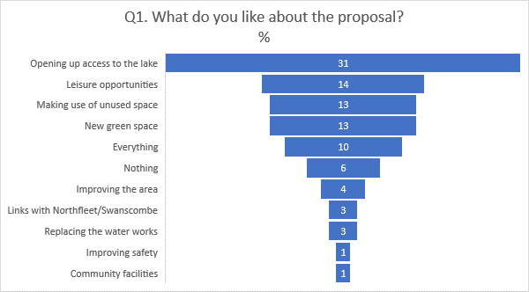

**Question 2: What do you not like about the proposals?**

This question sought open-ended comments. Responses have been grouped into key themes as shown in ***Chart 4***. Figures shown are percentages.

21% of people felt that too much housing was proposed in the draft Concept Plan, while 17% of people were fully supportive of the draft Concept Plan and said that there was nothing that they did not like about it.

**Chart 4**

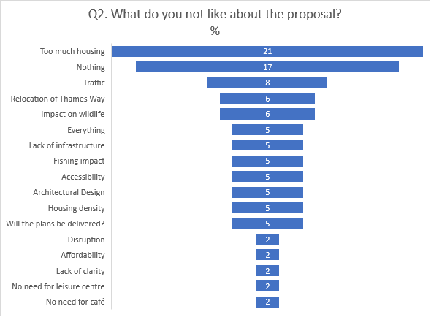

**Question 3: Is there anything you would like to see that has not been included?**

This was a free text question and responses were wide ranging, as shown in ***Table 2*** below. **Table 2**

|  |
| --- |
| **Comments from respondents** |
| **Leisure** |
| Year-round open water swimming, potential for scuba or free diving in the lake too.  Custom and Self build plots for local residents |
| Boathouse / swimmers changing facilities |
| Small playground for children |
| I would like to understand more about the recreation area. This is really important to me as I think is a great use of the space |
| Shopping and schools, natural walking areas not landscaped with skinny trees but proper wooded areas |
| Lakeside shops/bars as part of the residential development |
| More details of the parks and leisure centre |
| A good quality restaurant / public house |
| Maybe some more activities with and around the water |
| I would like to see facilities for open water swimming, public beach is the best option |
| I would like to see a 'beach area' where families could picnic and there is a safe access to the lake for paddling and swimming. I would like this to free of charge so that families who may not be able to afford the other leisure facilities still have some way of benefiting from and enjoying the area |
| Landscaped quiet areas for older people to walk and sit. Dog walker’s area, perhaps for dogs on leads with dog waste bins |
| 1. Scuba diving facility in the lake - need small area 20-30m deep with items to view e.g. Bus, plane, boat etc. 2. Pub/restaurant with outdoor seating |
| Shops, boats on the lake, more to offer for people to want to go swimming pool, beach |
| **Wildlife** |
| Clarity on the treatment within the existing railway sidings and pit. This area has recently been flattened and left with bare chalk to enable SI testing. The area was a natural habitat for insects, reptiles and birds. There have been a breeding pair of kites in the area for many years who hunted in this area. It must remain an ecological space, not overdeveloped. |
| Leaving the wildlife alone to continue living in the habit without any development. |
| Space to encourage local wildlife alongside pedestrian and community access |
| Nature doing its thing. Not money grabbers |
| More focus on maintaining it as a green open space for nature to thrive. With the prospect of the Swanscombe peninsula being turned into a theme park, natural habitats are being destroyed. We need to protect green open spaces not continually develop |
| I would like to see a clear ecology survey that lists what wildlife (flora and fauna) is currently there and in what numbers, compared to what life will be enabled to live there. What will introduced and what will be removed. If this can be done in a clear way indicating that changes, it would be a great way to get local people to buy in. I would also be very happy to be involved and to help with meetings and hand on work too |
| More detail on boosting biodiversity and natural habitats around the lake area |
| **Parking/Traffic** |
| There is lack of the parking spaces and convenient access to the park. It should be plan at early stage to have good number of parking spaces available to prevent people parking on the street |
| Good parking facilities - people will not always use public transport or come by foot - and it will impact local residents if the parking is not adequate for the potential demand |
| More residential parking, most households have at least 3 vehicles |
| We would like to see improved parking and traffic schemes in the surrounding area, particularly in order to mitigate the likely increased traffic flow |
| **Amenities/infrastructure** |
| Schools or nursery arrangement as more families will come to live in area |
| I do not think the current plans in Ebbsfleet are reflective of the diverse group of people that are joining the community- there is no provision for different faith groups and race groups. Will there by adequate infrastructure with regards to schools/library and GP facilities. Darent Valley hospital is already bursting with admissions, has there been any consideration of the implication of all these residents on hospital capacity or lack thereof? |
| Medical facilities |
| There needs to be more schools and GP surgeries to accommodate all of these new homes. Also the traffic can get really awful on Thames Way already, how will this be addressed? |
| A nice hospital, some GP surgeries and some places for people to get jobs |
| More lake, not so many houses; better road infrastructure; as the current layout won't cope with the increase in population |
| It is worth having a few office spaces in this area just like Heron Quays in Docklands |
| **Access** |
| There should be a pedestrian tunnel from the beacon building to the country park, so people don't have to keep crossing Springhead Road. It will merge the lake and the existing park into one entity |
| Easier access by foot to Ebbsfleet station from Thames Way. Currently you have to walk the perimeter of the car park to get to the station. A footbridge over the main road into the station pickup area would be good |
| Better connections to other areas. Green bridge links |
| Need to understand clearly the access detail to the pump house on the east end of lake and abstraction rights being maintained |
| How the existing communities at Northfleet North access these facilities. What through paths will connect? Will any enhancements be made to the existing communities such as upgrading and protecting small community halls and assets? Northfleet a high Street is in desperate need of attention; it is very neglected and deprived. Libraries and public use education, cultural hubs ... etc everyone should have access irrespective of means especially children. Green outdoor space...quality parks as this area is severely deprived of immediate outdoor green space...without having to jump in a car to get to one |
| Clear walking routes. Better link to Ebbsfleet FC and Northfleet. Improve area round EFC as currently very ugly |
| Integration with existing footpaths and parks - to include upgrading of existing (e.g. widening, low level lighting |
| **Housing** |
| Would like to see the possibility of including some self build, community led housing initiatives and cohousing |
| Plans for the Housing and retail or restaurant places around the lake places |
| Local history is a key element. I am a reasonably well known and experienced local historian, guide and speaker-but the staff at EDC seem to change so frequently that those whom I knew have gone and no one new has thought too much about heritage |
| **Fishing** |
| What will happen to Blue Circle Fishing Club? |
| To stay the same so that me and others can carry on fishing! |
| Fishing |
| As fishing has been vital for many during the lock down for exercise and mental health integrating fishing with the proposal could see another generation inspired by the sport as the history of the lake and fishing have gone back decades |
| **Other** |
| A tribute to the history of the lake, a heritage centre or memorial to those who lost their lives when the spring burst |
| A warden to look after the site. Pick up letter. May need toilet facilities plus someone to clean them. Security - make sure public are safe. A café - indoor and outdoor. Lifeguards to save swimmers from drowning - or life buoys present. Somewhere to walk a dog - poo bins needed |
| Management Plan after EDC depart |
| Nothing. Leave it alone |
| Leave it alone stop taking everything and anything |
| Ebbsfleet Garden City is its name - I would like to see wildflower meadows and a community garden |

**Question 4: The draft Concept Plan includes two options for the alignment of the Thames Way. Which option do you prefer?**

Respondents were asked to choose between:

Option 1: retain the existing alignment and   
Option 2: realign the road to the south

As shown in ***Chart 5*** below, respondents were broadly split between the two options. 46% chose option 2 while 43% supported option 1. A further 11% stated ‘other’ and their comments are shown in ***Table 3.***

**Chart 5**

**Table 3**

|  |
| --- |
| **Comments from respondents answering ‘other’** |
| Realign the road to incorporate speed attenuation curves, this section of road is occasionally used at night as a racetrack |
| It depends whether you anticipate future traffic to flow more towards the station or to continue along Thames Way. One day this road will need two lanes in each direction so make it a wide boulevard with loads of space each side |
| Concerned that benefits of option 2 will not justify cost and money could be better spent i.e. subsidizing leisure offer for local residents |
| Need to see a more detailed map to answer this question |
| Reconsider Springhead bypass |
| Other - leave it alone! |
| No preference |

**Question 5: Do you have any further comments about the Thames Way draft Concept Plan?**

This question invited free-form comments, with responses listed below in ***Table 4***.

**Table 4**

|  |
| --- |
| **Comments** |
| **General** |
| The concept looks good |
| This is a great idea, and I would like to see it get moving as soon as possible |
| Very good plan - fast implementation is key |
| Every plan starts claiming good intentions to improve the local community, then ends up dropping anything non-profit making and local residents are left with the greater demand on local services with almost no benefits |
| The information is sketchy due to being a concept, I would like to see more detailed concept drawings / visuals regarding each element individually |
| I think the plan is not very clear, we need more details |
| Long overdue, and welcomed |
| As a resident on Springhead Road, we would like to see a much more detailed map of the complete area |
| Yes. Is this a joke? How much more can crammed into Northfleet. |
| Speed up the development! |
| Once the planners and developers have completed their work they will move onto the next project. It is VITAL that the views of the local community are taken into account as we will have to live with it |
| I hope when finished you will appoint accessible park wardens to look after the area and have designated wildlife areas. I have always thought that area has so much waster space that could be put to better use with the right investment. Fingers crossed you will bring it to fruition |
| You seem to think that by calling this overdevelopment a new name constantly that will make people think it exists. Ebbsfleet is not the name of the area. It is SWANSCOMBE which has existed for hundreds of years |
| Let it stay the same! |
| **Leisure** |
| This will provide so much outdoor water sports that the area is desperately lacking. There is no place to swim or kayak within 30 minutes’ drive |
| Having walking trails would be great as currently this area is mainly lorries and therefore awful to attempt to walk around |
| Like better use of lake for recreational activities and beach |
| Lake access needs to be free and dog friendly |
| Love the idea of a beach - maybe beach huts and boats |
| I like to walk and anywhere that can be enhanced to make that a more pleasurable activity, away from the heavy traffic, would be a definite bonus |
| **Housing** |
| With regards to housing, 1,300 units will mean potentially an additional 4,000, if not more inhabitants to what is a congested area particularly regarding road traffic problems and pollution. Why so many? How many of these will be affordable and or/ ring fenced for local families...? |
| Include later living options? Multi-generational? Key worker housing |
| This could be a fantastic improvement for the local area; however houses should be capped at 900/1000 |
| Unconvinced of attractiveness of housing on site of sewerage works |
| **Road realignment** |
| I would be happy to keep the road where it is but make it a more attractive roadway |
| If realigned, make the road layout more pedestrian friendly (line the route with trees + push cyclists out into the road instead of sharing pavement) |
| The additional traffic would require dual carriageway status for Thames Way from the junction with the A2 to its junction with Springhead Road Option 1 requires the existing road to be upgraded whereas option 2 requires a new road ,given the heavy use of the road the upgrading should be a condition of the planning process and should be undertaken prior to the development taking place |
| Don't see why it has to move |
| Look forward to more detailed plans and an understanding of the impacts on the local highways network. Thames Way, a straight, open and direct route, it is already enjoyed by many pedestrians and cyclists, and is not overlooked by housing. Multiple swimming and triathlete clubs have already expressed an interest in inputting into the leisure plans |
| Please provide the new route for all HGV from Northfleet East industry park to avoid Rosherville Way and Thames Way. They generate too much noise and pollution and have negative effect on your visual plan. All Heavy Traffic should be from Crete hall through TARMAC industry park with the short possible link to A2 |
| **Infrastructure** |
| Not relocating the water treatment works will have much impact as appears it's only being relocated away from road and towards the housing development |
| Is the plan for the Tarmac Cement & Lime plant to stay there long term next to Northfleet Embankment? If not, then the tracks can be changed and it will give you much better options for connecting the leisure centre to the North East |
| I feel sorry for all the people who have their houses on the proposed realignment. They are just new-built, and their houses are really close to the road. (Unless I have misunderstood where the road is going. It isn't very clear) |
| We would like strong links with Northfleet, accessibility wise, and support for existing businesses and facilities. For this development to enhance and not be detrimental |
| No mention of improvement of drainage when it rains a few areas flood the road |
| Weight of traffic and poor infrastructure GP and dentist |
| **Environment** |
| Any development south of current Thames Way damages one of the last wildlife areas in the valley which also enhances the environment and the biological health of the upper reach of the river |
| I'd like to see as many features built for recycled materials as possible and for the whole site to be as eco-friendly as possible. Completely No Smoking anywhere on site |
| **Amenities** |
| Rather than even more housing why can't the lake be surrounded by a nice hospital, some GP surgeries and some places for people to get jobs? |
| Will the people of Northfleet and anyone else still be able to use footpaths/access NU7A and NU14? I would like a paid job as a warden (part/time) if the project goes ahead. I used to be a qualified zookeeper at ZSL London Zoo. I am currently doing volunteer work at a local food bank |
| **Fishing** |
| Just leave it alone it’s been a fishing lake for years and years leave it as it is |
| Do not exclude fishing or make limited areas fishable |
| **Other** |
| Speaking for a local group: **- ACCESS** We welcome the repurposing and opening up of a currently virtually inaccessible area (Blue Lake) giving access to new recreation facilities and parks for local people. This will provide much needed green/blue space and exciting opportunities. Will there be a door-to-door survey of all local residents to promote and gather views on the scheme?  **- Pedestrians:** We do stress the need to improve direct pedestrian access to these from the surrounding areas, especially over the railway line.  **- Parking:** We are also concerned that, in the early planning stages, the scheme will not address the need for sufficient, well planned parking, in all developments and facilities. The residents of Northfleet would clearly welcome a scheme that could actually improve parking conditions in the local area, and it is particularly important that the scheme does not blight already congested areas such as Springhead Road. In particular, we could not support the Beacon Building, which could be a very exciting hub for the area, if we cannot see adequate provision of parking for this building within the development in the early planning detail, such that users would not attempt to park in the adjacent residential areas.  **- LEISURE CENTRE** A leisure centre with emphasis on outdoor and water sports centre would be welcome and would make full use of the lake and its environs.  **- DEVELOPMENT** The proposal for 1300 houses is recent and was not in the earlier strategic plans. It will reduce considerably the originally proposed size of the park, (by over a third), which we understand was 14 hectares. We gather that waterways will ‘bleed’ into the development, with the intention of integrating it. However we feel there is a real possibility that as the parameters are currently vague, this development area will increase and so will put the parks viability and ecology at risk. We’d also like to understand how the affordable housing would be integrated with the scheme. Once some more definite plans are in place, we would very much welcome the opportunity to comment but we would support an absolute limit on the amount of development to this area, to secure the long-term future of the park.  **- WASTE WATER PLANT** A new enclosed wastewater treatment plan “with a clean and odourless facility” will be very welcome. Can we assume its capacity will take account of all proposed development as the constraints of the site would make any expansion difficult?  **- ENVIRONMENT** We understand that wildlife and ecology surveys will be published in June on the EDC website, and you state that ‘the variety of animal and plant life in the area’ will be protected and enhanced. We would obviously encourage the enhancement of wildlife in the area, (the lake was restocked for fishing around 10 years ago but there is little else for locals) and suggest that good non-pedestrian corridor routes for land-based wildlife to reach either end of the lake (from Northfleet Urban country park to Ebbsfleet River Park) are provided as these are as yet unclear on the existing plans. Bearing in mind the impact of infilling the lake, re-profiling the banks of the lake and creating a platform for the development area, how will the protection of existing wildlife and then the enhancement of it be achieved? You mention that ‘inert’ materials will be used for the infilling; can we assume this will not be building materials/debris/landfill from other sites? **- ALIGNMENT OF THE THAMES WAY** In both schemes the impact on the existing local residents will be low, but we are of the opinion that re-routing the Thames Way as suggested would have other impacts and therefore favour Option 1 where it is kept in its current position. Presumably, there will be or has been a road traffic survey to ascertain the impact of any changes, which we would be interested to see. Our reasons for objecting to Option 2, without seeing the detail of the proposal, which is currently vague, are as follows:  **1** Another road and bridge over Ebbsfleet River will be disruptive to its habitat, as the construction of the bridge to Springhead Parkway has been.  **2** If we have understood correctly, it will increase traffic considerably at the junction of the A2260 to International Way which is the Main entrance to Ebbsfleet International Station and already congested. Use of Ebbsfleet Station will surely increase with the occupation of so many new houses, exacerbating the problem.  **3** HGVs slowing down and inevitable queuing at the new junction would increase pollution.  **4** The short section of Road on the A2260 from the Junction at International way to the current junction with the Thames Way could possibly need to be enlarged to accommodate the increased volume of traffic.  **5** You said that the roadway of the current Thames way would be retained for local traffic in any case, but it is not clear if this would still be connected to the old part of the Thames Way.  **- FUNDING** It was mentioned that the housing development areas were necessary for the economics of the project. We would like to understand more about where funds for the different parts of the Blue Lake Project would come from, and which bodies would be ultimately responsible for running the leisure facilities. In particular, should Thames Way Option 2 proceed, does the funding for the road come from the developers (in whose commercial interest the road is being built) or would you be arguing that the cost should be part of your planning obligations? |

**Question 6: We are keen to capture the history of the local area so that we can record it and make sure the past helps shape the future. Do you have any memories or interesting facts about Blue Lake and the surrounding area that you would like us to record?**

Respondents were encouraged to submit written comments to this question. Responses are shown in ***Table 5*** below.

**Table 5**

|  |
| --- |
| **Comments** |
| The flooding of the old quarry supposedly there is abandoned equipment under the water |
| There were once watercress beds and a much larger extent of biodiverse areas until the rail link carved them up |
| The blue lake is on top of a natural spring which is where the name springhead comes from |
| I have heard that the lake was formed overnight when a quarry digger hit a natural underground spring - is this true? |
| There should be a trail around the lake explaining history like one on Gravesend river front |
| We call the walkways up from Ebbsfleet and across to Northfleet ‘Jurassic Park’ - it's the cages! They would not be missed if a more attractive, safe set of walkways were put in |
| I think any elements of the working river and industrial heritage would be good to incorporate |
| Rumour has it that the lake was formed when diggers dug through into water and the quarry then filled. The diggers are still under the water allegedly. Not sure if this is true or not but might be worth investigating |
| The fact that it isn't called Blue Lake, that's just a local nickname for Sawyer's Pit/Lake |
| I have lived in Northfleet all my life and as a child many of us would sit by the Blue Lake in the summertime and have picnics and swim by the shores of the lake |
| The Blue Lake is a beautiful place with tranquil scenery, unfortunately it has never been developed to its full potential |
| Leave it alone. By asking people this comment I take it you have already decided to go ahead so why you even bothering to ask people what they think |
| Fishing has been historical past time with the lake for many of the factory workers, which holds historical fish possibly the British record carp during 70s/80s. Was known as Sawyers Lake |
| 40 years or so ago, the Blue Lake was used by adventurous youngsters for swimming, fishing and leisure- it was the sort of place that one’s parents banned, but their views were disregarded! |
| I don't. But I doubt you'll get the stories from people like me (middle-aged white woman who answers surveys). I suggest contacting the local churches. There are people who attend that have been in the area all their life. Ask them to help you set up a meeting where people can share their stories. There will be loads of great stories. St Botolph’s church might be able to help. I noticed the vicar there attended one of the meetings |
| As a child, we used to play and have free reign navigating the Blue Lake surrounds, building camps or visiting friends fishing there. For some years it’s changed to private access and fishing rights only. That’s a tragic loss. We also had the Blue Circle sports and social club, which was an immaculately kept green space containing football pitches, bowling greens, tennis courts and an Art Deco Social Club....all of this made available not only for the Blue Circle workers and their families but also the wider community who could freely participate and enjoy the surroundings (including beautiful trees and the fleet stream). It was a peaceful clean oasis amongst an otherwise heavily quarried, polluted disregarded area...being replaced by Ebbsfleet International Station. It’s time for Northfleet to be given back some kind of decent natural environment and given some hope at last. We do matter and we can contribute |
| We often walk past Blue Lake on our way from Northfleet Urban Park to the river Ebbsfleet and my dog is desperate to go for a swim |
| Contact *** who does talks of the area and guided walks (not of the Blue Lake of course) |
| Ask *** (Local Historian). |
| Many people remember the splendid Blue Circle sports ground which was an important recreational and social facility, and an extra dimension of the history of cement making and other industries in the Thames corridor. The prehistoric and Roman history is well known. An important figure in local history was Robert Pocock (1760-1830) who is remembered in the naming of the Wetherspoon pub in Gravesend. Among his many interests was a fascination with botany and natural history, and the Ebbsfleet Valley and Swanscombe Peninsula was one of the many local areas which he explored, recording his findings in his journal and preserving plant specimens, some of which are kept in the archives of the Natural History Museum in London. As a young adult and student Marie Stopes was also interested in botany and fossilised plant remains, and she conducted a study of plants and the river in the Valley (her parents had a house in Swanscombe for a time) |
| Rubbish, all you want to do is destroy the history and rewrite it to turn it into something it's not. CANCEL CULTURE! WOKE!! |
| Perhaps not with that immediate area, but Gravesend/Northfleet area was famous for the 'Rotherville Gardens' - a 19th century pleasure garden built in a disused chalk pit. It covered 17 acres and was famous with travellers from London by a Thames paddle steamer |
| It was very cold and no swimming was allowed |
| Blue Lake - kids used to swim in it |
| There's so much local history from cement, paper even Dr Who was filmed in the area. There's also lots of history in St Botolph’s and the Coach & Horses immediately above Blue Lake |
| Blue Lake was previously called Sawyers Lake, named after the farm there before it was a lake |
| Blue Circle Cement staff could walk round the lake but it was private with no public access at that time. The road that is now Thame Way was also private with gates that were closed on Christmas Day |
| Keep it the same |

**Question 7: We're looking for ideas for the name of the new neighbourhood - please provide any suggestions here.**

Respondents were asked to suggest names for the area. Responses are listed in ***Table 6*** below.

**Table 6**

|  |  |
| --- | --- |
| **Suggested name** | **Number of mentions** |
| Blue Lake | 9 |
| Blue Lake Park | 4 |
| Ebbsfleet Lake/s | 3 |
| Blue Lake Vista | 2 |
| Blue Lagoon | 2 |
| Lake View / Lake View Village | 2 |
| Beacon Lake | 2 |
| Blue Lake Village | 1 |
| Ebbsfleet Riviera | 1 |
| Ebbsfleet Waters | 1 |
| Ebbsfleet South | 1 |
| Bluewater Lagoon | 1 |
| Lakeside Park | 1 |
| Ebbsfleet Blue Lake Park | 1 |
| Quarry lake | 1 |
| Springhead country park & water sports centre | 1 |
| The Tetanus Basin - especially if you build the rusty needle landmark | 1 |
| Springhead Pools | 1 |
| Northfleet Lakeside | 1 |
| Blue Lake Development | 1 |
| Disney housing estate!! | 1 |
| Chalk Pit Lake | 1 |
| Northfleet Lakelands | 1 |
| Blue Lake Green | 1 |
| *Avoid* Bluewater Park and Blue Circle Lake | 1 |
| SWANSCOMBE | 1 |
| Little Haven, Blue Pool Nature reserve, Blue Lake Resort, Ebbsfleet Nature Park | 1 |
| Blue Circle Ave | 1 |
| Blue Lake Recreation Park | 1 |
| Liverpool (I'm biased) | 1 |
| Watercress - was a plant that I believe grew freely in the area many years ago - maybe something incorporating that | 1 |
| Northfleet, Rosherville | 1 |

**Question 8: how did you hear about this consultation?**

This question asked respondents to choose from a list of options to understand how they heard about the consultation. Responses are summarised in ***Chart 6*** below, with values as a percentage.

Responses under ‘other’ included email, via a fishing club and a local councillor and via direct conversation with EDC.

**Chart 6**

**Question 9: Which consultation events have you attended/are due to attend?**

This question asked respondents to choose from a list of options to understand how they heard about the consultation. Responses are summarised in ***Chart 7*** below.

**Chart 7**

**Demographic information**

Many respondents to the online survey (58) agreed to share information about their ethnicity, age, gender and employment status as shown in ***Charts 8, 9, 10 and 11***.

**Chart 8**

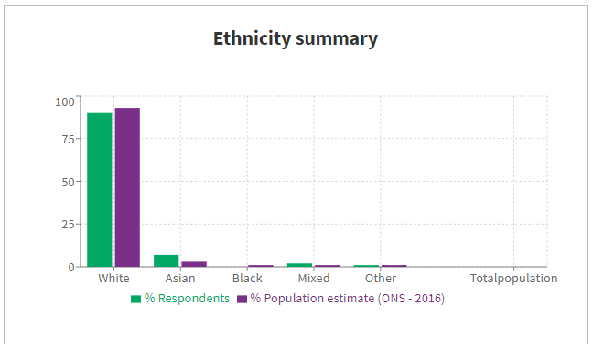

**Chart 9**

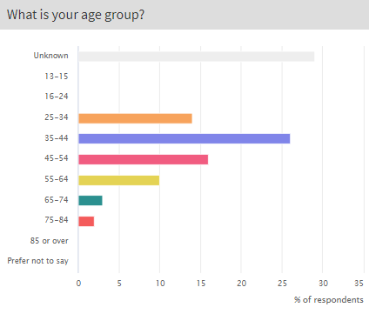

**Chart 10**

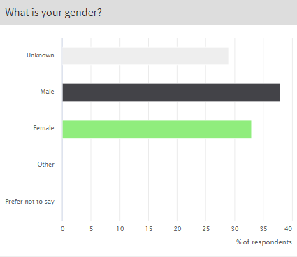

**Chart 11**

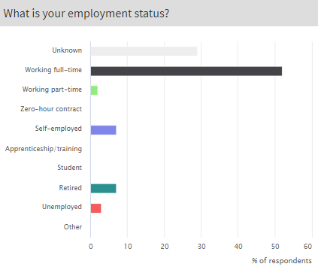

**Location of respondents**

Survey respondents – both online and offline – were asked to share the first four characters of their postcodes to indicate where they live. The maps below display the locations.

**Map 1**

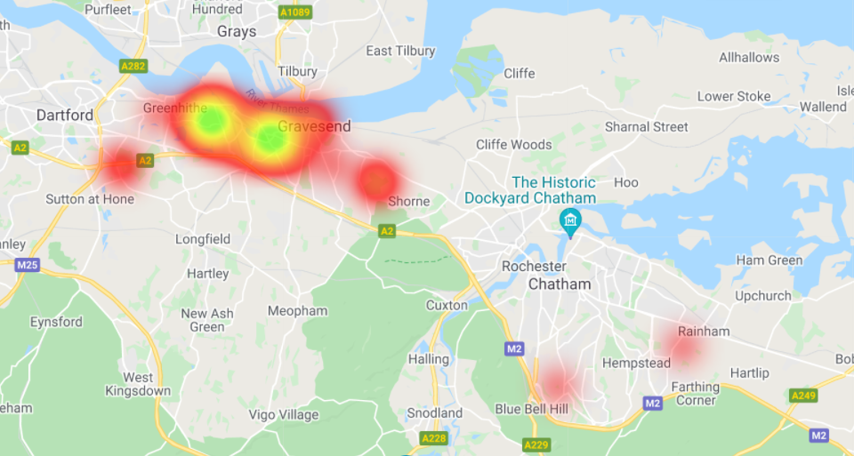

**Map 2**

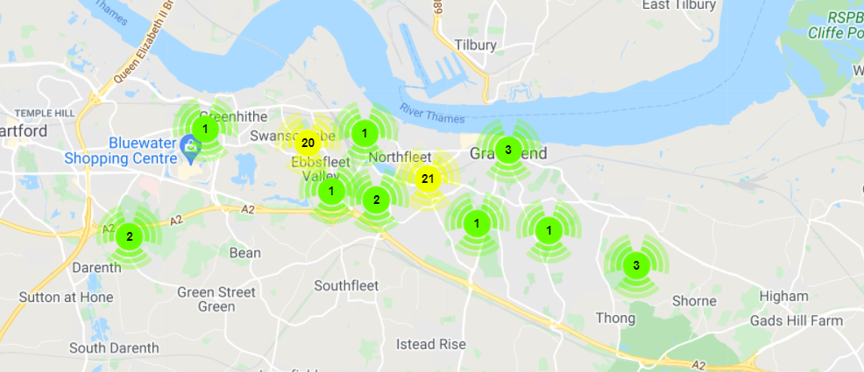

**Feedback via the consultation email / Freepost address**

An email address was set up to receive people’s queries and comments. This was monitored by Athene on a regular basis. Eight substantive emails about the proposal were received. These emails can be seen at ***Appendix K.***

No letters were received via the Freepost address, other than the completed feedback surveys.

**Feedback via the Freephone number**

A total of eleven messages were received via the Freephone number. All of the calls related to booking a place on a webinar or a telephone surgery. One call also mentioned that they would like to find out how the proposals would affect their business, and another made the point that local schools are oversubscribed.

**Comments received via social media**

Two comments were received across the social media posts about the consultation. One commented “Flats by a lake? With more cars?” and the second commented “Wildlife natural park with hiking trails”.

# 6. Conclusion

EDC has proactively sought to engage and consult with stakeholders, local residents and businesses about the draft Concept Plan for the Thames Way Development Area.

Information about the draft Concept Plan and the public consultation has been widely promoted and people have had an opportunity to provide feedback. The consultation took place between 11 May 2021 and 8 June 2021 and included online meetings with key stakeholders, three public webinars and a telephone surgery.

Overall, 68 individuals completed the online survey on the project website and a further 13 people submitted a completed feedback form via Freepost. 70% submitted positive comments about the draft Concept Plan. Many people were encouraged by the idea of opening up access to Blue Lake and the proposed increased leisure opportunities. There were also positive comments about the proposal to replace the existing Wastewater Treatment Works and how this would help to reduce odour.

The main concerns / points raised about the proposal were:

* The area does not need any more housing
* Lack of infrastructure/schools/healthcare
* Potential impact on wildlife
* Concerns over access to Blue Lake for fishing
* Increased traffic
* Access and parking

When asked for views on whether to realign the Thames Way, responses were split fairly equally, with 46% favouring realigning the Thames Way and 43% supporting leaving it as it is.