Contents
Introduction 1
Overview 2

Ebbsfleet

Swanscombe to Castle Hill and

access into Ebbsfleet Academy 3

Ackers Drive connection 5

Greenhithe

London Road to Greenhithe Station 6

Bean Road 8

Northfleet North

Northfleet High Street 10

Northfleet South and Painters Ash

Springhead Road 12

National Cycle Network 177

to Hall Road 14

Hall Road 16

Have your say 18

Introduction
We are undertaking early consultation on eight walking and cycling improvement schemes across Ebbsfleet, Greenhithe and Northfleet. These schemes form part of the Green Corridors Programme. They seek to provide high-quality, connected routes to support a shift towards sustainable modes of travel.
Kent County Council places a high priority on encouraging sustainable and active travel. We want to support making walking and cycling safer, easier, and inclusive for all.
Residents require a transport network that provides a variety of travel choices to support a growing population. We have worked closely with Ebbsfleet Development Corporation to develop some initial proposals in eight locations which connect existing routes and provide residents with more opportunities to choose cycling and walking for their day-to-day journeys.
This consultation asks for feedback on the following schemes:
- Ebbsfleet:
- Swanscombe to Castle Hill and access into Ebbsfleet Academy
- Ackers Drive connection
- Greenhithe:
- London Road to Greenhithe Station
- Bean Road
- Northfleet North:
- Northfleet High Street
- Northfleet South and Painters Ash:
- Springhead Road
- National Cycle Route 177 to Hall Road
- Hall Road

Objectives

Overview
The Green Corridors Programme aims to encourage and enable sustainable active travel by making walking and cycling an attractive and realistic choice for short journeys both for work and leisure.
The principle behind the Green Corridors Programme is to support a walking and cycling culture by making routes more attractive, safer and better connected. This will ultimately improve the quality of life for residents, support health and wellbeing by incorporating physical activity into everyday routines and reduce the number of vehicles on the road, improving air quality.
The programme will work alongside other projects, such as Kent Active Travel, to:
- deliver and maximise the quality of cycling and walking networks across Ebbsfleet Garden City by providing fully linked up cycle and pedestrian routes.
- create user friendly and appealing cycle and pedestrian routes encouraging experienced and inexperienced cyclists alike.
- encourage active travel and increase activity levels so that walking and cycling become main forms of transport.
- connect new and existing communities through the provision of connected cycle and walking routes.

Why are these schemes needed?
Ebbsfleet Garden City has excellent regional and international connections, but on a local level new villages and communities are separated from existing communities and local hubs by the lack of connecting walking and cycling infrastructure.
Many areas of the garden city are still disjointed and do not have a comprehensive network of local transport connections required for the area to grow sustainably.
More widely, Kent faces challenges resulting from a lack of good quality cycle routes. Less than 2% of residents currently cycle to work, lower than the regional and national average. This programme provides an opportunity to make a substantial and long-lasting change.
The Covid-19 pandemic has led more people to take up cycling and walk more often. The changing patterns of behaviour has provided opportunities to invest in making local places easier and more pleasant to travel by foot or cycle.

How will the schemes be funded?
The total budget for this programme is £7.4m which will be split across all schemes. This funding is being provided by Ebbsfleet Development Corporation. Kent County Council will be delivering the schemes.

Ebbsfleet
Link from Swanscombe to Castle Hill and access into Ebbsfleet Academy

Scheme proposal
This scheme aims to better connect Swanscombe with Castle Hill by improving the existing Public Right of Way footpath (DS20).
The scheme also proposes to provide a safer and more direct route into Ebbsfleet Academy for school pupils. This will be achieved by creating a new pedestrian footpath entrance at the south-eastern corner of the car park linking to the existing path within the school grounds. This will direct pupils away from the narrow footway on Southfleet Road.
This means residents, particularly commuters to Ebbsfleet International and Ebbsfleet Academy pupils, can travel from their home to their destination sustainably.

What is being considered in the design?
- Environmentally sensitive: Improvements to the footpath will be designed to minimise impact on the existing vegetation and wildlife. This will include limiting the required digging during construction, so the tree roots are not impacted. Removal of vegetation will be kept to a minimum and replaced as part of the scheme. There is also an opportunity to introduce new landscaping as part of the construction of the footway into Ebbsfleet Academy.
- Pupil safety: Pupils and visitors to Ebbsfleet Academy will have a dedicated pedestrian entrance to the south of the school and will no longer need to cut through the car park entrance.
- Accessibility: The new school entrance will be sloped and in line with accessibility standards to allow unimpaired access for pedestrians with reduced mobility.

Summary of improvements:
The scheme will:
- resurface and make minor level changes to the Public Right of Way.
- formalise the accesses to the Public Right of Way footpath from Whitecliffe Road.
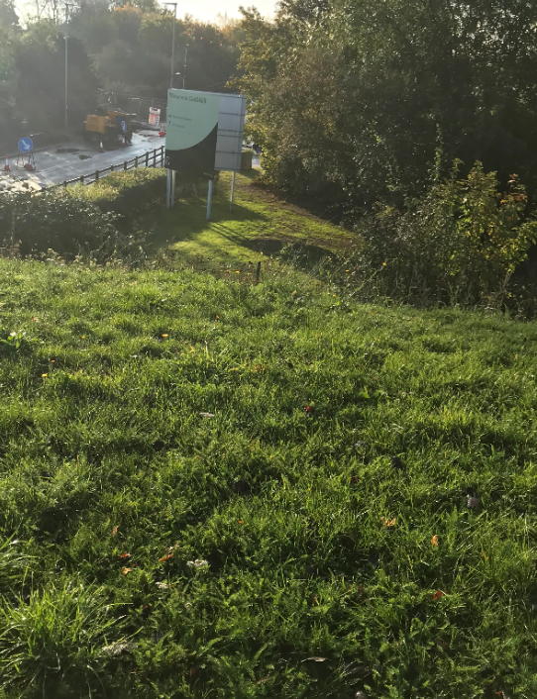
- construct a pedestrian access into Ebbsfleet Academy from the corner of Whitecliffe Road, providing an additional entrance into the school.

Figure 1: Location identified for additional access into Ebbsfleet Academy. Photo taken from top of slope looking south.

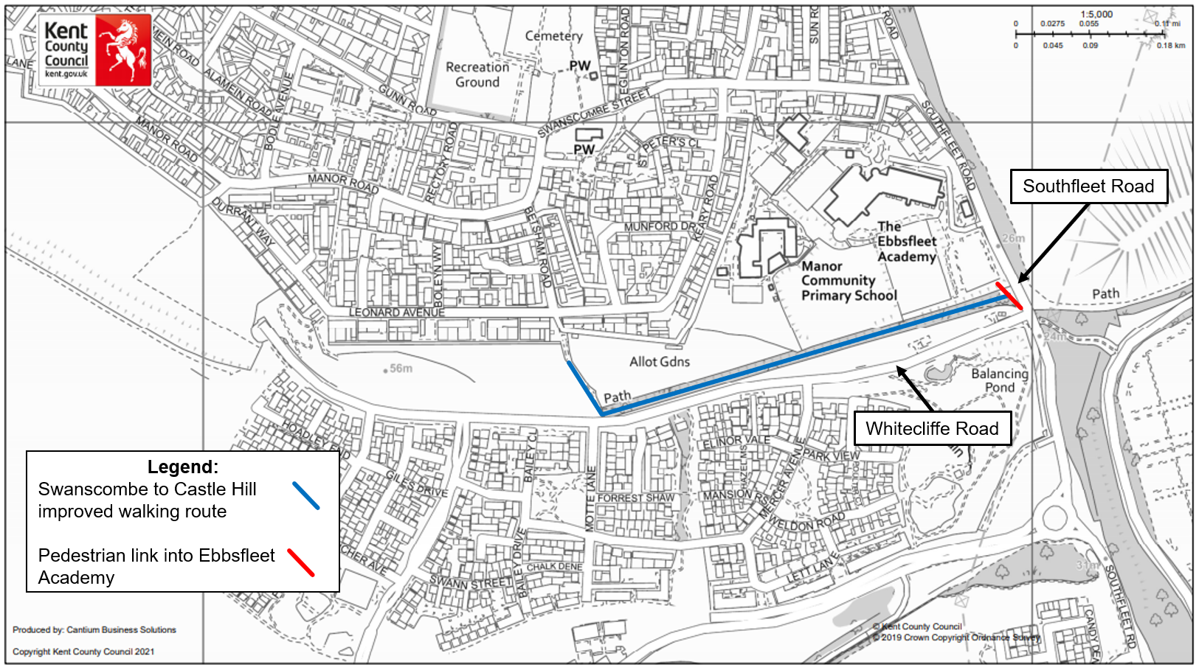

Ebbsfleet
Link from Swanscombe to Castle Hill and access into Ebbsfleet Academy

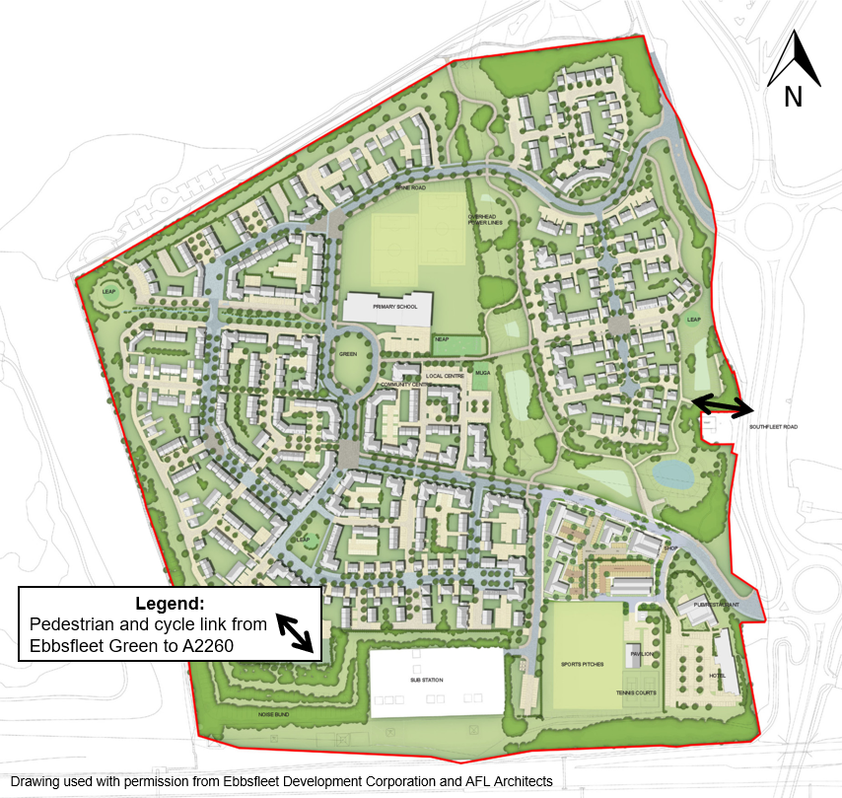

Scheme proposal
This small scheme will provide a new shared pedestrian and cycle entrance to the residential area of Ebbsfleet Green from the A2260.
This link has been identified as a key missing connection into Ebbsfleet Green. This will provide a connection for those commuting to Ebbsfleet International by cycle or foot.

What is being considered in the design?
- Accessibility improvements: This will better connect Ebbsfleet Green with the A2260, meaning residents can travel from their home to their destination more directly, encouraging active and sustainable travel.
- Landscaping: Removal of vegetation will be kept to a minimum and replaced as part of the scheme. To do this the design will make use of existing gaps in the landscape to locate the shared cycle and footpath link.
- Signage: The proposal will include directional signage to Ebbsfleet Green.

Summary of improvements:
- Create a better shared walking and cycle connection from Ebbsfleet Green to the A2260, providing a more convenient route to Ebbsfleet International Station.

Ebbsfleet
Ackers Drive Connection

Greenhithe
London Road to Greenhithe Station

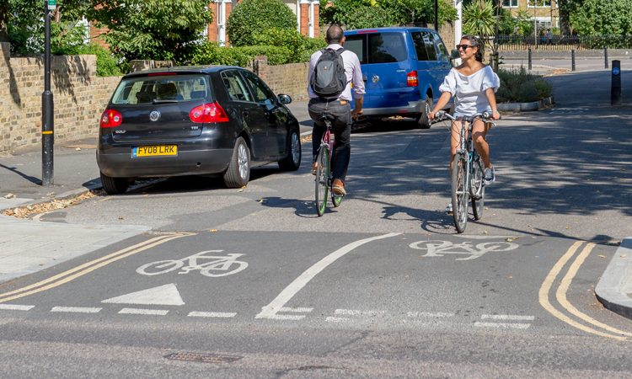

Scheme proposal
The route to Greenhithe Station from St Clement’s Way Roundabout is a popular pedestrian and cycle connection, however cyclists are currently directed onto the carriageway at Ivy Villas and only re-join the shared path past the junction of Riverview Road. Improving this route for cycling would create a more attractive environment, encouraging active commuting to and from Greenhithe Station.
This scheme proposes to introduce a quiet, more direct cycle route from St Clement’s Way Roundabout to Greenhithe Station. This would be achieved by reallocating space on Station Road for cyclists, upgrading the existing steps and constructing a shared use slope from Station Road to Station Approach for cyclists and pedestrians.
Consideration would also be given to improving cycle provision on Ivy Villas, however more detailed design is required to identify possible options. One idea could be to introduce a design like that shown in Figure 2. Vehicle access would be maintained for residents, but cyclists would be invited to use the full road width, to maintain a continuous, direct and clearly signed cycle route.

What is being considered in the design?
- Landscape improvements: There is the opportunity to significantly improve the environment in this area. Although the slope construction will require the removal of some vegetation, this would be replaced with higher quality trees and shrubs designed to encourage wildlife in urban areas. There is also an opportunity to introduce new landscaping on the verge next to Station Road.
- Improved crossing facilities at Riverview Road: Pedestrians will be able to cross more easily.
- Residential parking: The current proposals do not involve

Figure 2: A possible concept for Ivy Villas.
removing parking from Ivy Villas and access will be maintained for residents. To allow for the improved pedestrian crossing facilities on Station Road, some of the under used parking bays may have to be removed to allow for safe cycling and walking.
- Placemaking improvements at Greenhithe Station: Improvements could include planters, new signage and improved crossing facilities for pedestrians and cyclists along the Fastrack route.

Summary of proposed improvements:
- New direct cycle route from Ivy Villas to Greenhithe Station.
- Construction of a slope connecting Station Road with Station Approach.
- Improved crossing facilities at Riverview Road to provide safer crossing points for pedestrians.

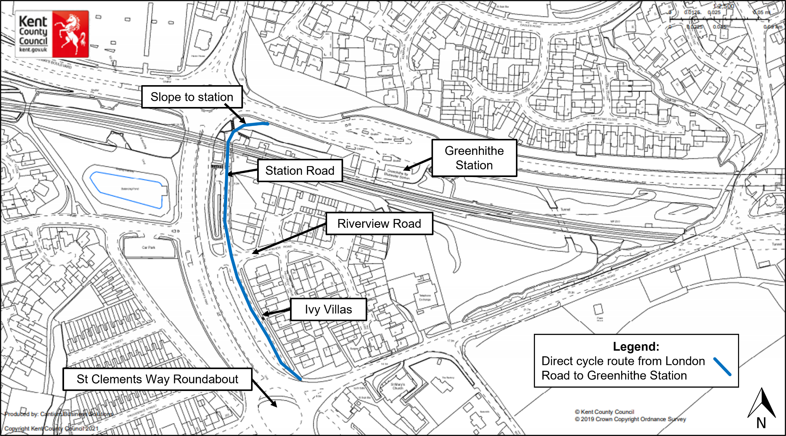

Greenhithe
London Road to Greenhithe Station

Greenhithe
Bean Road

Scheme proposal
Bean Road is a residential road that is parallel to St Clements Way (B255). As well as flats and houses, Bean Road also serves multiple care homes and care facilities. Despite this, the existing footway is narrow and is often blocked by refuse bins, making the footway inaccessible for those with reduced mobility or using pushchairs or prams.
As the Whitecliffe villages are built in Ebbsfleet, the footfall on Bean Road is likely to increase, as it provides a more direct route to Greenhithe Station.
To address these issues, this scheme proposes to widen the footway along the entire length of Bean Road. To achieve this, it is suggested that Bean Road should be made one-way with vehicles travelling southbound only. This means the parking can be kept as it is.
By widening the footpath, the scheme aims to encourage walking as a means of transport to local destinations such as Greenhithe Station and Bluewater.

What is being considered in the design?
- Improved pedestrian facilities: The proposed scheme includes widening and resurfacing the footway. This means pedestrians will be able to walk the whole stretch of Bean Road footpath without stepping into the road to avoid bins or street clutter.
- Residential parking: We recognise that parking on Bean Road is vital for residents and visitors. Therefore, the scheme proposes to keep all existing parking on Bean Road. Parking bays would be formally marked out but this would not involve introducing permits.

- Emergency vehicles: There may also be opportunity to mark out an emergency vehicle bay on the road. This will be investigated further during the detailed design phase of the scheme.
- One-way traffic: As the suggested scheme proposes to keep the parking on Bean Road as well as widen the footpath, there is not enough space to retain two-way traffic on the road. Therefore, the scheme proposes to introduce one-way southbound traffic on Bean Road. The northern entrance to Bean Road would remain two-way to facilitate access to McDonald’s. This will also minimise vehicles from the nearby new development using Bean Road as a cut through.
- Landscaping: This scheme will not impact the mature trees or vegetation to the west of Bean Road. This is private land and will not be included within the scheme.

Summary of proposed improvements:
- Widen the existing footway along the entire length of Bean Road.
- Removal of unnecessary street furniture from the footway on Bean Road.
- Make Bean Road one-way, with traffic travelling Southbound only.

Further consultation
We want to understand the views of residents, businesses, and stakeholders at this early stage and incorporate them into our proposals. We will carry out a second stage of consultation on this scheme once the design has progressed.

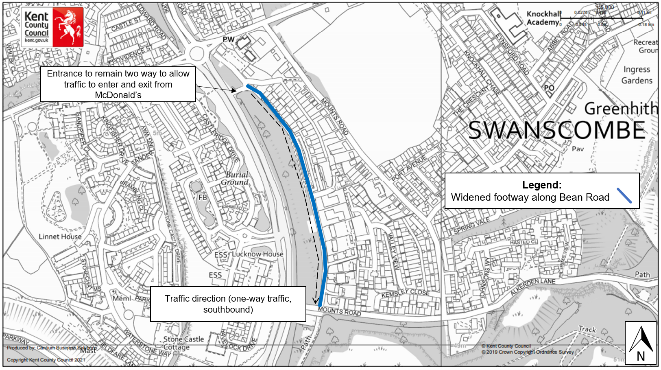

Greenhithe
Bean Road

Northfleet North
Northfleet High Street

Scheme proposal
This scheme aims to create a new cycle route along Northfleet High Street providing a direct, convenient, and safe active travel option through Northfleet. The route will help cyclists access Northfleet Station, businesses on Northfleet High Street, schools as well as new and existing residential areas.
Where possible, the new route is proposed to be separated from traffic and pedestrians to allow for a greater number of cyclists than can be supported by shared space alone.
The route will support the Gravesend to Northfleet scheme proposed as one of the Kent Active Travel schemes and will support the future development of the cycling network in the area.

What is being considered in the design?
- Improved pedestrian crossing facilities: There are several side roads that exit onto Northfleet High Street. We will look to move the crossing points, so they are aligned to the pedestrian desire line. A desire line is the place where a pedestrian would naturally cross a road if there were no obstacles (such as railings).
- Bus stops: When developing the designs, we will need to consider the best way for cyclists to travel through bus stops to reduce the risk of conflicts with pedestrians. Options include ‘bus stop bypasses’ which route cyclists around a bus stop and ‘bus stop boarders’ which take cyclists in front of a bus stop.
- Landscaping: There is opportunity to significantly improve the landscaping and vegetation on Northfleet High Street. This will not only encourage wildlife, but also visually improve the area.

- Space constraints: There are several locations along Northfleet High Street where the width of the footways are restricted by the building frontages. Where there are these constraints, several options will be considered, such as narrowing the carriageway slightly so that the footways can be widened. The design will also make use of currently unused or poorly designed road space. These options will be presented in a further consultation.
- Placemaking improvements: These improvements could include new signage and removal of unnecessary street clutter.

Summary of proposed improvements:
- New cycle route along Northfleet High Street which is separated from traffic and pedestrians.
- Reallocation of road space to widen footways and crossing improvements for pedestrians and cyclists.
- The design will take into consideration space requirements for bus services operating along the B2175.
- Localised improvements along the new cycle route including removal of street furniture clutter and improved signage on the route.

Further consultation
We want to understand the views of residents, businesses and stakeholders at this early stage and incorporate them into our proposals. We will carry out a second stage of consultation on this scheme once the design has progressed.
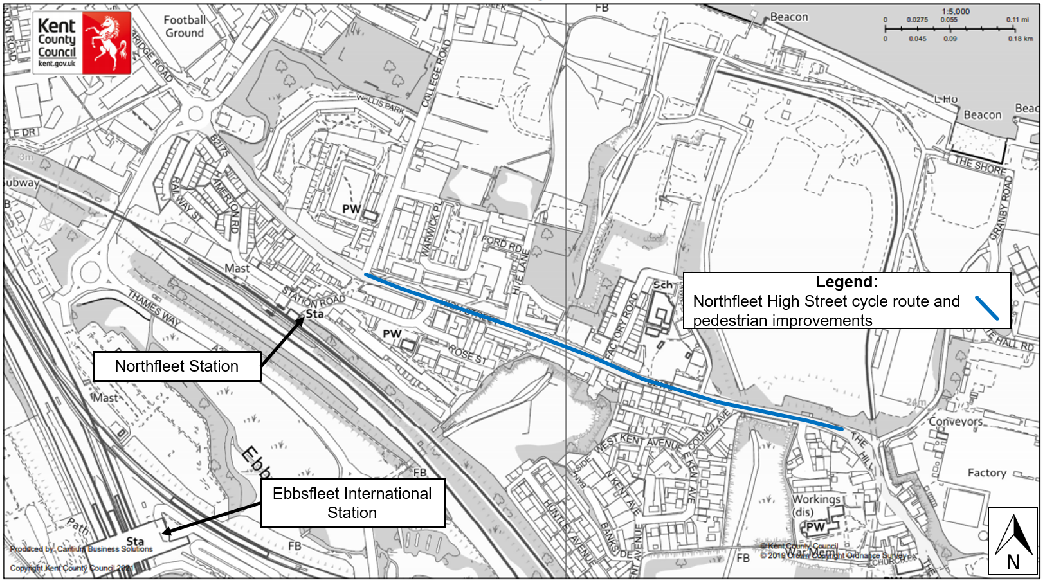

Northfleet North
Northfleet High Street

Northfleet South and Painters Ash
Springhead Road

Scheme proposal
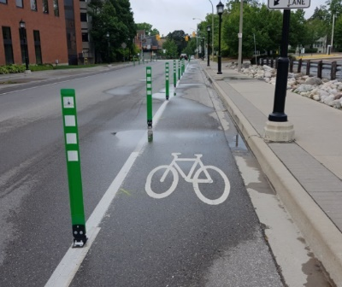
This scheme aims to create a new cycle route both sides of Springhead Road providing a direct, convenient, and safe option for cyclists. By providing a safer, more accessible cycle route the scheme seeks to encourage more walking and cycling for work and leisure.
Figure 4: An example of flexible posts used elsewhere in Kent
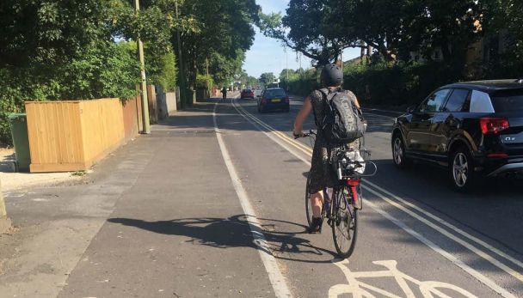
Where possible, the new route is proposed to be separated from traffic and pedestrians to allow for a greater number of cyclists. The scheme proposes to use a stepped cycle track (as shown in Figure 3) to separate the cycle lane from both the road and the footpath. This type of separation means that flexible posts (Figure 4) are not necessary and access to driveways can be maintained.
Figure 3: Example of a stepped cycle track in Oxfordshire. Source: Cycle Infrastructure Design LTN 1/20 Image Credit PJA; Licenced under the Open Government Licence v3.0

What is being considered in the design?
- Bus stops: When developing the designs, we will need to consider the best way for cyclists to travel through bus stops to reduce the risk of conflicts with pedestrians. Options include ‘bus stop bypasses’ which route cyclists around a bus stop and ‘bus stop boarders’ which take cyclists in front of a bus stop.
- Space constraints: To construct the cycle lane, the design will make use of currently underutilised or poorly designed road space.
- Placemaking improvements: These improvements could include new signage and removal of unnecessary street clutter.
- Residential parking: Consideration will also need to be given as to whether space for parking would need to be relocated or reduced in certain sections to provide the necessary width for the cycle route. We would seek to minimise the impact on parking where possible.

Summary of proposed improvements:
- New stepped cycle route along Springhead which is separated from traffic and pedestrians.
- The design will take into consideration space requirements for bus services operating along Springhead Road.
- Removal of street furniture clutter and improved signage on the route.

Further consultation
We want to understand the views of residents, businesses and stakeholders at this early stage and incorporate this feedback into our proposals. We will carry out a second consultation on this scheme once the design has progressed.
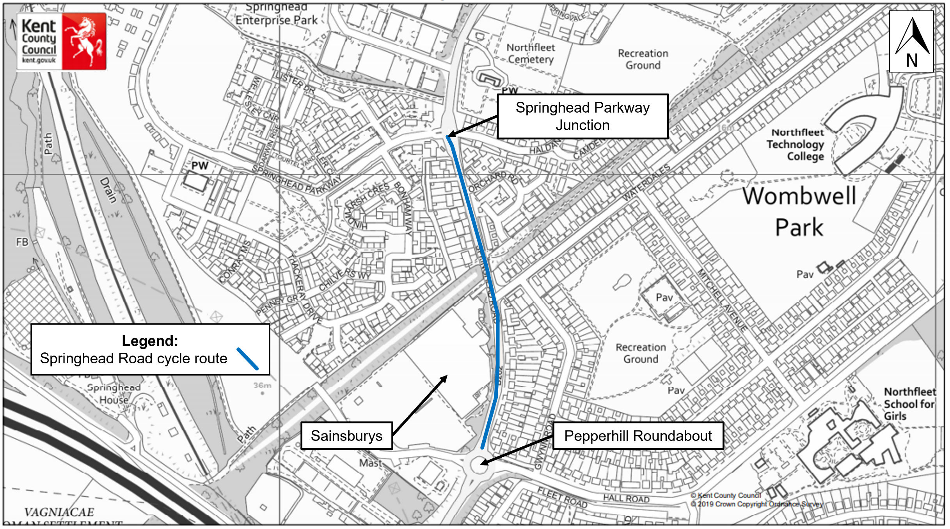

Northfleet South and Painters Ash
Springhead Road

Northfleet South and Painters Ash
National Cycle Network (NCN 177) to Hall Road

Scheme proposal
This scheme aims to create a new cycle route linking Hall Road with the National Cycle Network. This cycle link has been identified as a key missing part of the growing cycle network in Gravesham. The scheme proposes the following two improvements:
- to create a direct cycle link from NCN177 to Masefield Road.
- to provide a new cycle route with signage from this new cycle link to Hall Road.
By providing a safer, more accessible cycle connection to this network, the scheme seeks to encourage more cycling for work and leisure.

What is being considered in the design?
- Cycle signage: This scheme will introduce an on-street cycle route, which will be marked with signs. There are two options for this route that are being considered.
- Direct cycle link to NCN 177: This link, although new, will follow the path of the well-used route (Figure 5) from Masefield Road to the National Cycle Route. Although this link will predominately be a route for cyclists, it will be a shared surface. The surface will be a light colour to complement the park-like feel of the area.
- Placemaking improvements: These improvements could include new signage and removal of unnecessary street clutter.
- Landscaping improvements: Vegetation may have to be thinned where the new link will access the NCN177. However, there are several opportunities to plant additional trees and shrubs throughout the route to encourage wildlife in the area.

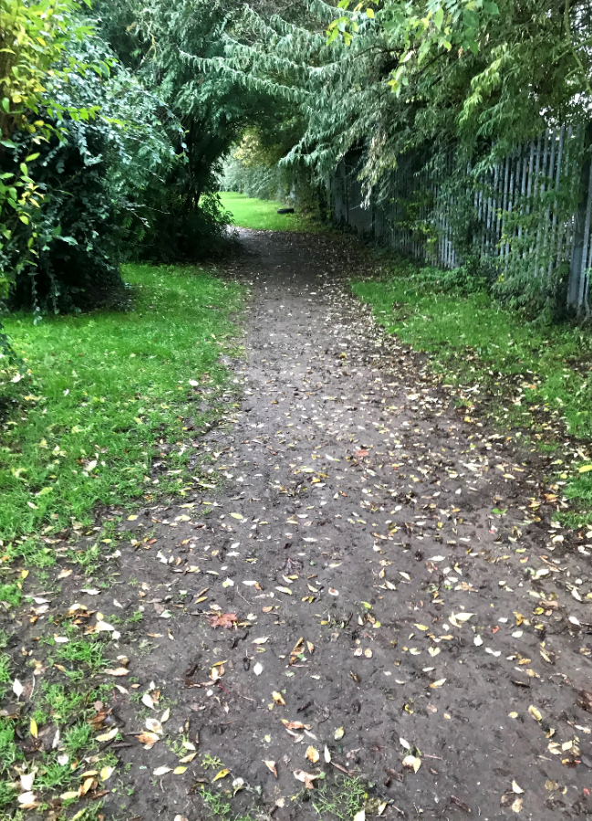
Figure 5: Current informal path used by both cyclists and walkers.

Summary of proposed improvements:
- Construction of formal cycle link from Masefield Road to NCN177.
- Removal of street furniture clutter and improved signage on the route.
- Improved landscaping across the route.

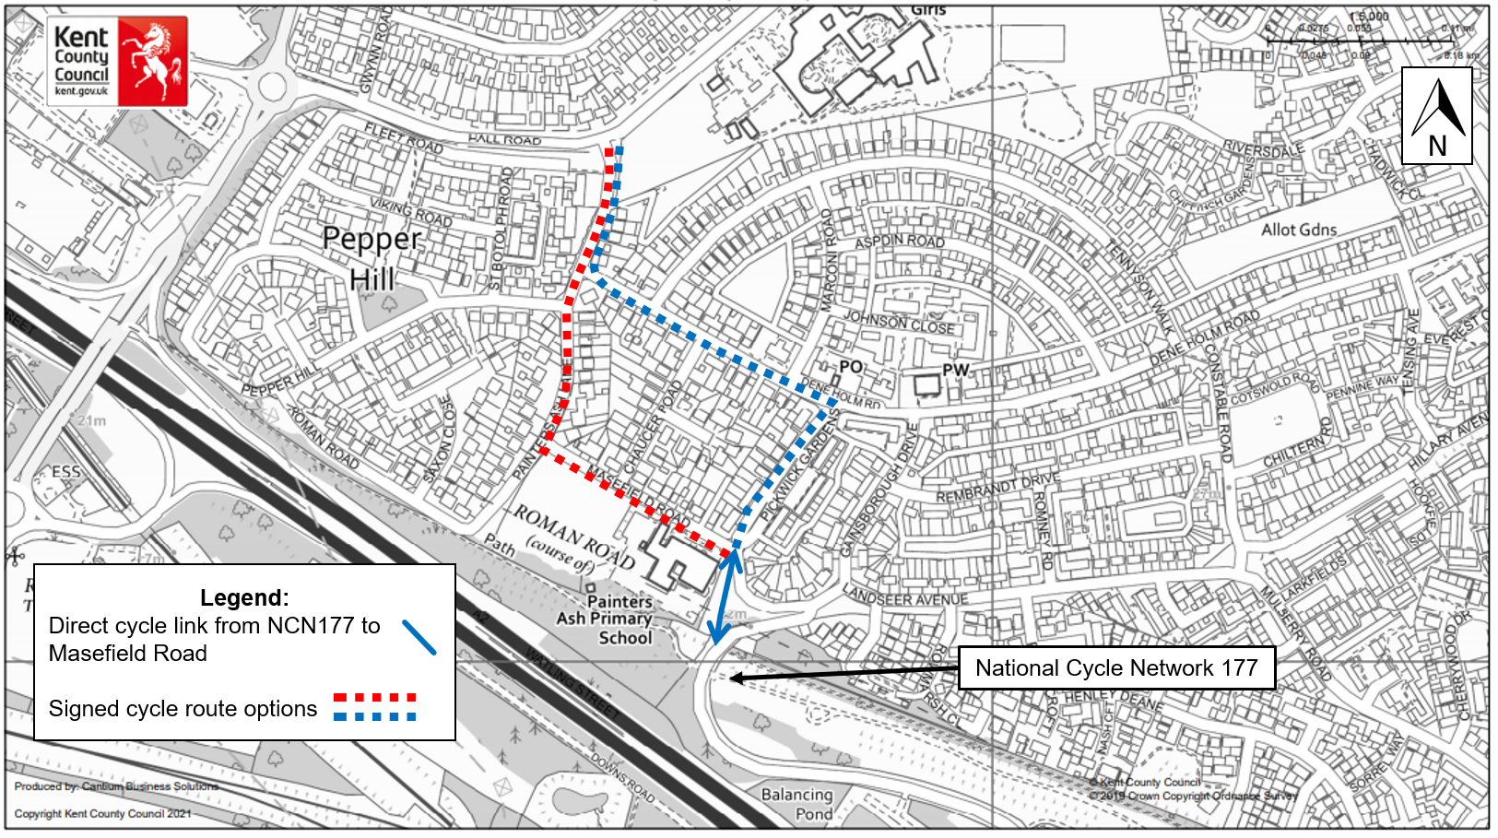

Northfleet South and Painters Ash
National Cycle Network (NCN 177) to Hall Road

Northfleet South and Painters Ash
Hall Road

Scheme proposal
This scheme aims to create a new cycle route on Hall Road providing a direct and convenient option for cyclists. By providing a safer, more accessible cycle route the scheme seeks to encourage more cycling for work and leisure.
It is proposed that the new route be next to the footpath separated from the road. When developing the design, we will consider the best way to minimise the risk of conflicts with vehicles and pedestrians.

What is being considered in the design?
- Improved pedestrian and cyclist crossing facilities: The design will improve the crossing facilities on Hall Road close to Painters Ash Lane. This will enable the route to link up with the previous scheme (page 14 -15) and provide a safe crossing for both pedestrians and cyclists.
- Options for the cycle route: We will consider different options for the cycle route, including: a shared footpath and cycleway; a cycleway that is separated from the footpath by a white line; or physically by a kerb. Options will be presented at the second consultation once the design has been developed in more detail.
- Residential parking: We know that residents of Hall Road currently park informally on the entrances approaching their driveways. We will seek to minimise the impact on this parking where possible.
- Landscape improvements: There is opportunity to improve the landscape and vegetation along Hall Road to complement the existing trees. The design will incorporate the existing trees minimising the impact on vegetation where possible. If any trees

must be removed, they will be replaced with high-quality trees and shrubs designed to encourage wildlife in urban areas.
- Placemaking improvements: These improvements could include new signage and removal of unnecessary street clutter.
- Improved pedestrian facilities: The proposed scheme may include resurfacing the footway so that pedestrian access is improved for residents and pupils of Northfleet School for Girls.

Summary of proposed improvements:
- Installation of a new cycle route on Hall Road which is separated from traffic.
- The design will take into consideration space requirements for pedestrians and parked cars.
- Localised improvements along the new cycle route including removal of street furniture clutter and improved signage.
- Landscaping improvements across the route.

Further consultation
We want to understand the views of residents, businesses, and stakeholders at this early stage and incorporate this feedback into our designs. We will carry out a second consultation on this scheme once the design has progressed.

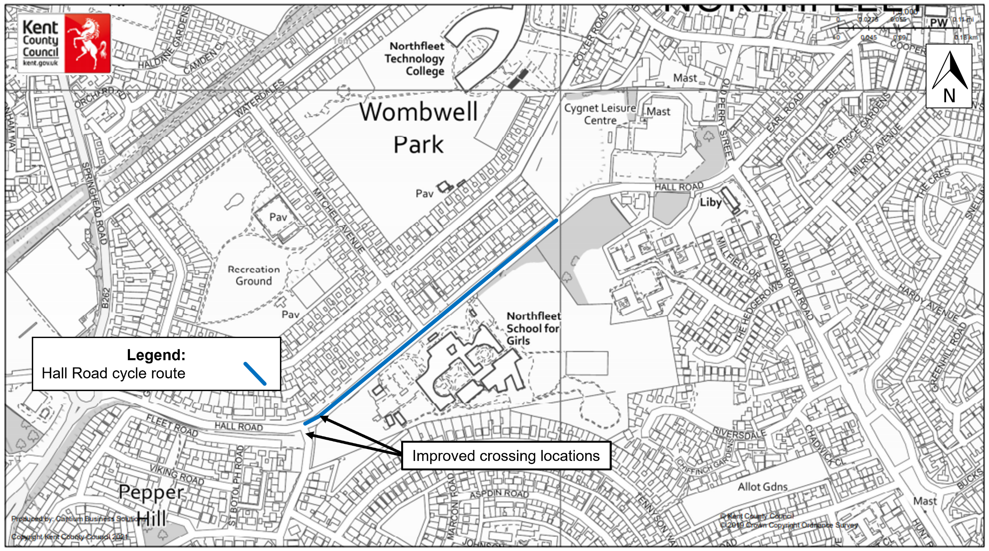

Northfleet South and Painters Ash
Hall Road

Help us shape our designs

Have your say

We want to understand and incorporate the views of residents, businesses, the travelling public and other stakeholders into our proposals. This feedback will be vital in helping to shape how the schemes are developed and taken forward.
This consultation will run for six weeks from 21 July to 31 August 2021.
You can provide feedback by completing the questionnaire which is available on our website: www.kent.gov.uk/greencorridors
Feedback will be reviewed and analysed following the closure of the consultation. The findings will then be compiled into a consultation report and made available on our website.
In the next six months, we will carry out a second consultation on the larger schemes presented in this booklet, with more detail of the designs to ensure that they best suit the needs of local communities.

Equality Impact Assessment (EqIA)
To help ensure that we are meeting our obligations under the Equality Act 2010, we have undertaken an Equality Impact Assessment (EqIA) on this phase of the Green Corridors Programme. This is to assess the impact our proposals could have on people due to their protected characteristics (age, sex, gender identity, disability, race, religion or belief, sexual orientation, pregnancy or maternity, marriage and civil partnership and carer’s responsibilities). The EqIA is available to view at kent.gov.uk/greencorridors or on request.

The schemes in this programme will deliver positive impacts by providing safe places to walk and cycle, which will benefit pedestrians of all ages and abilities.
During the works, alternative routes will be provided for pedestrians with barriers and ramps for those with visual and mobility impairments as required and in accordance with industry standards.
No long term, or significant adverse effects have been identified however, the EqIA will be updated after the consultation to consider any relevant information we receive.

Contact us
If you have any queries about any of the schemes or require hard copies, please contact us at greencorridors@kent.gov.uk or call 03000 41 81 81. Please use the reference ‘Green Corridor Programme’ to identify the schemes.

Alternative formats
For any alternative formats, please email alternativeformats@kent.gov.uk or call 03000 42 15 53 (text relay service number 18001 03000 42 15 53). This number goes to an answering machine, which is monitored during office hours.




